
Subject: Programming with Java
ASSIGNMENT No : 16
TITLE : Write a Java program to create and handle a user-defined exception.

Name: Avdhoot Mohite Class: CSE A2
PRN: 25070122056 Batch:25-29

Problem Statement
Write a Java program to create and handle a user-defined exception.
Learning Objectives
To create and implement custom exceptions for application-specific error handling.
Theory:
User-defined exceptions are created by extending the Exception class. They allow developers to define meaningful exceptions for specific business logic. Custom exceptions improve program readability and simplify debugging by providing descriptive error messages. They are widely used in enterprise software and validation systems.
Outcome
The programs were successfully implemented to create and handle user-defined exceptions in Java. Custom exceptions were used to validate the age of a person in the voting system and driving license system. The programs displayed appropriate messages when the entered age was below 18 and confirmed eligibility when the age was valid.
Conclusion
Thus, the experiment successfully demonstrated the creation and handling of user-defined exceptions in Java. Custom exception classes were created by extending the Exception class and were used to handle application-specific validation conditions. This helps in making programs more readable, reliable, and easier to debug.

Exercise
1. Create a Voting System that throws a custom exception if age is below 18.
Code:
import java.util.Scanner;

// User-defined exception
class InvalidAgeException extends Exception {
public InvalidAgeException(String message) {
super(message);
}
}

public class assignment16a {

static void checkEligibility(int age) throws InvalidAgeException {
if (age < 18) {
throw new InvalidAgeException(
"You are not eligible for voting. Age must be 18 or above."
);
} else {
System.out.println("You are eligible for voting.");
}
}

public static void main(String[] args) {
Scanner sc = new Scanner(System.in);

System.out.print("Enter your age: ");
int age = sc.nextInt();

try {
checkEligibility(age);
} catch (InvalidAgeException e) {
System.out.println("Exception: " + e.getMessage());
}

sc.close();
}
}

OUTPUT:
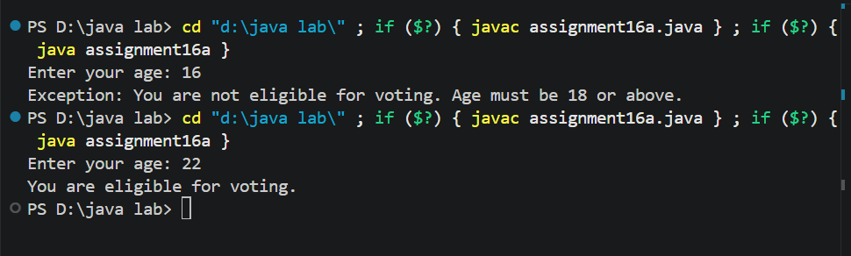

2. Create a Driving License System that throws a custom exception if the user's age is below 18. If the age is valid, display that the user is eligible for a driving license.
Java Program
import java.util.Scanner;

// User-defined exception
class DrivingLicenseException extends Exception {
public DrivingLicenseException(String message) {
super(message);
}
}

public class assignment16b {

static void checkEligibility(int age) throws DrivingLicenseException {
if (age < 18) {
throw new DrivingLicenseException(
"You are not eligible for a driving license. Age must be 18 or above."
);
} else {
System.out.println("You are eligible for a driving license.");
}
}

public static void main(String[] args) {
Scanner sc = new Scanner(System.in);

System.out.print("Enter your age: ");
int age = sc.nextInt();

try {
checkEligibility(age);
} catch (DrivingLicenseException e) {
System.out.println("Exception: " + e.getMessage());
}

sc.close();
}
}

OUTPUT:
